**Database Design**

**Entity-Relationship Diagram**

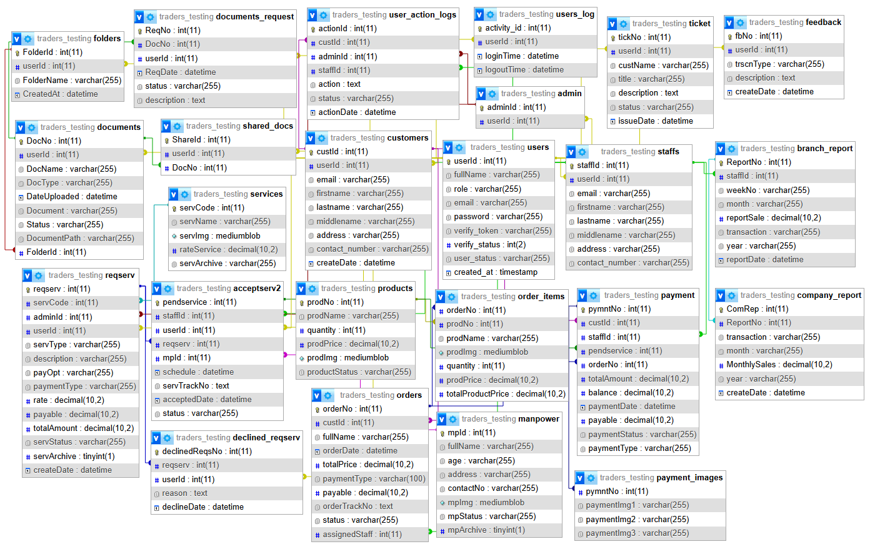

Figure 101: **Entity-Relationship Diagram**